NBTX10442_WEEK-8_LAB-B

Q1. /**********Program to check whether 2 strings are same or not****/

#include<stdio.h>

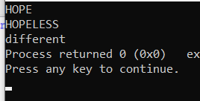int main()

{

char a[20],b[20],c=0,i=0;

gets(a);

gets(b);

while(a[i]!='\0' || b[i]!='\0')

{

if(b[i]==a[i])

c=0;

else

{

c=1;

break;

}

i++;

}

if(c==0)

printf("same");

else printf("different");

}

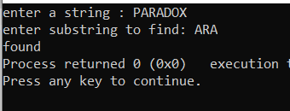Q2. /****Program to check substring in a string*****/

#include<stdio.h>

int main()

{

char a[20],b[20],c=0,i=0,j;

printf("enter a string : ");

gets(a);

printf("enter substring to find: ");

gets(b);

while(a[i]!='\0')

{

j=0;

while (b[j]==a[i]) //to find substring

{

j++;

i++;

if(b[j]=='\0') //substring found

{

c=0;

break;

}

else

c=1;

}

if(c==0)

break;

i-=(j);

i++;

}

if(c==0)

printf("found");

else

printf("not found");

}

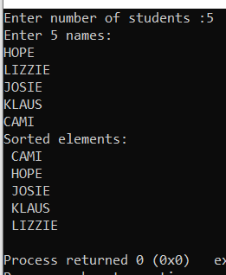Q3. /***********C program for Sorting names of students************/

#include<stdio.h>

typedef char string[50];

int main()

{

string str[50];

char temp[50];

int count, i, j;

printf("Enter number of students :");

scanf("%d",&count);

printf("Enter %d names: ",count);

for(int i=0;i<count;i++)

{

scanf("%s",&str[i]);

}

for(i=count-2;i>=0;i--)

{

for(j=0;j<=i;j++)

{

if(strcmpi(str[j],str[j+1])>0)

{

strcpy(temp,str[j]);

strcpy(str[j],str[j+1]);

strcpy(str[j+1],temp);

}

}

}

printf("Sorted elements: \n");

for(i=0;i<count;i++)

printf(" %s \n",str[i]);

}

EXTRA QUESTIONS

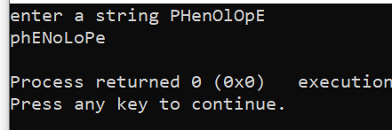Q1. /**Program to toggle the case of each character in a string**/

#include<stdio.h>

int main()

{

char a[50],i=0;

printf("enter a string ");

gets(a);

while(a[i]!='\0')

{

if(a[i]>64 && a[i]<91)

a[i]+=32;

else

a[i]-=32;

i++;

}

puts(a);

}

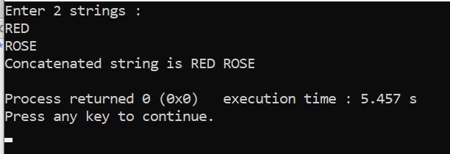Q2. /***program TO concatenate two strings***/

#include<stdio.h>

int main()

{

char a[20],b[20];

int i;

printf("Enter 2 strings : \n");

gets(a);

gets(b);

i=strlen(a);

a[i]=' ';

a[i+1]='\0';

strcat(a,b);

printf("Concatenated string is ");

puts(a);

}